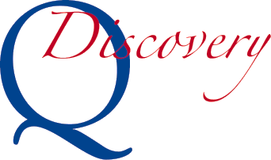
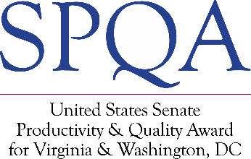
Intent to Apply
Submission of this form signals your organization’s intention to participate in the Virginia SPQA Discovery Program. SPQA will expect a Discovery Self-Assessment in not less than 60 days and not greater than 6 months from the date of this Intent. Please complete and email this form to U.S. Senate Productivity and Quality Award (SPQA) at Programs.Services@spqa-va.org.

Date: Click or tap to enter a date.
Contact Information

Organization Name:
Highest Ranking Official:
Title:
Point of Contact (POC):
POC Title:
POC Phone:
POC E-mail:
Organization Address:
City, State, Zip: | , ,

Business Information

Organization Category: | Manufacturing/ Service Education Healthcare Government
Organization Structure: | Profit Not-For-Profit | # of Employees:
Main Product of Service:

SPQA Charge Information

Your “Intent to Apply”  fee is $750.00 | SPQA will send an invoice and contact you to arrange payment.

Important: Please retain a copy of this form, as it will need to be resubmitted with your Self-Assessment and Participant Fee.

