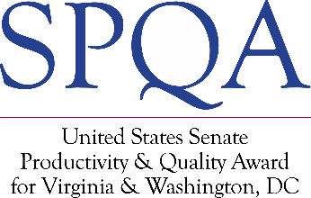
COMMITMENT Level
Intent to Apply
Submission of this form signals your organization’s intention to participate in the Virginia SPQA Commitment Level. Please complete and email this form to U.S. Senate Productivity and Quality Award (SPQA) at Programs.Services@spqa-va.org.

Date: Click or tap to enter a date.
Contact Information

Organization Name:
Highest Ranking Official:
Title:
Point of Contact (POC):
POC Title:
POC Phone:
POC E-mail:
Organization Address:
City, State, Zip: | , ,

Business Information

Organization Category: | Manufacturing/ Service Education Healthcare Government
Organization Structure: | Profit Not-For-Profit | # of Employees:
Main Product of Service:

SPQA Charge Information

Charges for participation is based on organization size: | • $1,200 (> 50 Full-Time Employees)  • $600 (< or = 50 Full-Time Employees)
SPQA will send an invoice and contact you to arrange payment.

IMPORTANT: Please retain a copy of this form, as it will need to be resubmitted with your Participation Fee.

