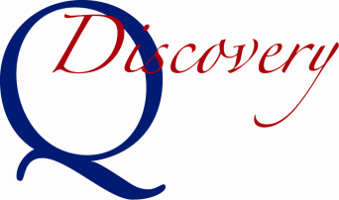
Intent to Participate

Submission of this form signals your organization’s intention to participate in the Virginia SPQA Discovery Program. SPQA will expect a Discovery Self-Assessment in not less than 60 days and not greater than 6 months from the date of this Intent.
Please complete and email this form to U.S. Senate Productivity and Quality Award (SPQA) at
Programs.Services@spqa-va.org.

Date: Click or tap to enter a date.
Contact Information

Organization Name:
Highest Ranking Official:
Title:
Point of Contact (POC):
POC Title:
POC Phone:
POC E-mail:
Organization Address:
City, State, Zip:

Business Information

Organization Category: | Manufacturing/Service Education Healthcare Government
Organization Structure: | Profit Not-For-Profit | # of Employees
Main Product or Service:

SPQA Information

Your “intent to participate fee” is $750.00: | SPQA will send an invoice and contact you to arrange payment

Important: please retain a copy of this form as it will need to be resubmitted with
your Self-Assessment and Participation Fee.

