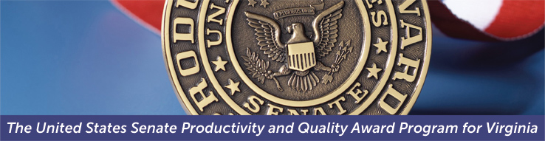
2019 Award Intent to Apply
Submission of this form signals your organization’s intention to apply for the 2019 SPQA Award. Please complete and email this form to programs.services@spqa-va.org. Upon receipt of this form, you will be invoiced for the non-refundable $500.00 Intent to Apply fee. This intent to apply form must be sent to SPQA by November 16, 2018. For questions email programs.services@spqa-va.org.

Date of this Intent:
Contact Information

Organization Name:
Highest Ranking Official:
Title:
Point of Contact (POC):
POC Title:
POC Phone:
POC E-Mail:
Organization Address:
City, State, Zip:

Business Information
Organization Category: | Manufacturing/Service Education Health Care Government Nonprofit
Organization Structure: | Profit Not-For-Profit | # of Employees in VA or D.C:
Is your organization a business unit of a larger parent organization?: Yes No If yes, what is the name of your parent organization? ______________
Also, if yes, are you a distinct entity within the parent organization that can respond to the Criteria? Yes No
What is your Main Product or Service? _________________________
^{#1} Site Visit Date Choices: Choose 2 consecutive weekdays from April 29 – May 10, 2019
1st choice: Click or tap here to enter text. 2nd choice: Click or tap here to enter text.
3rd choice: Click or tap here to enter text. 4th choice: Click or tap here to enter text.
SPQA Information
Your application is for: | 2019 SPQA Award 2019 ACE
Have you applied before? | Yes No | If “yes” what years?
In submitting this Intent to Apply, your organization is committing to:
- An Examination Team Site Visit, which occurs on two consecutive days sometime between late April and mid-May.
- An Examination Report Feedback Meeting, which occurs for up to two-hours on a day between mid-July and early August.
- 3 separate Fee Payments to be invoiced by SPQA at the time of submission – Intent to Apply Fee: $500; Application Fee: $2000; Site Visit Fee: $2500. Your POC will be invoiced via email.

