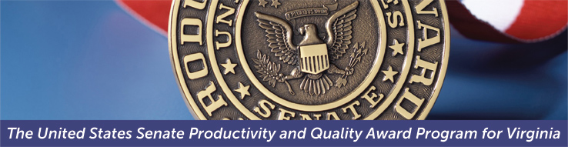
2019 Award Intent to Apply
Submission of this form signals your organization’s intention to apply for the 2019 SPQA Award. Please complete and email this form to programs.services@spqa-va.org. Upon receipt of this form, you will be invoiced for the non-refundable $500.00 Intent to Apply fee. The intent to apply letter must be sent to SPQA by November 16, 2018.

Date of this Intent:

Contact Information

Organization Name:
Highest Ranking Official:
Title:
Point of Contact (POC):
POC Title:
POC Phone:
POC E-Mail:
Organization Address:
City, State, Zip:

Business Information
Organization Category: | Manufacturing/Service Education Health Care Government Nonprofit
Organization Structure: | Profit Not-For-Profit | # of Employees in VA or D.C:
Is your organization a business unit of a larger parent organization?: Yes No

If yes, what is your parent organization? ______________

Also, if yes, are you a distinct entity within the parent organization that can respond to the Criteria? Yes No

What is your Main Product or Service? _________________________

SPQA Information
Your application is for: | 2019 SPQA Award 2019 ACE
Have you applied before? | Yes No | If “yes” what years?
The “intent to apply fee”: | Will be sent separately following receipt of SPQA’s invoice
In submitting this Intent to Apply, your organization is committing to pay the remaining fees and fully support:
- An Examination Team Site Visit, which occurs on two consecutive days sometime between late April and early June*.
- An Examination Report Feedback Meeting, which occurs for up to two-hours on a day between late July and late August*.
*Note: Exact dates and times are determined in February and March.

Important: Please retain a copy of this form for your files and include one copy with your application package. Revised J April 2018

